Polyhedra

Definition
# Source: AI Source: Provided by: [Data Path: Persons Table -> ID Column: 1, Name_En Column: Motasem Essam] -> From: [ChatGPT] on [7/25/2026]
A polyhedron is a three-dimensional geometric solid whose boundary consists of a finite number of flat polygonal faces. These faces meet along straight edges, and the edges meet at vertices.
Examples of polyhedra include cubes, cuboids, prisms, pyramids, and many other solids with flat polygonal faces.
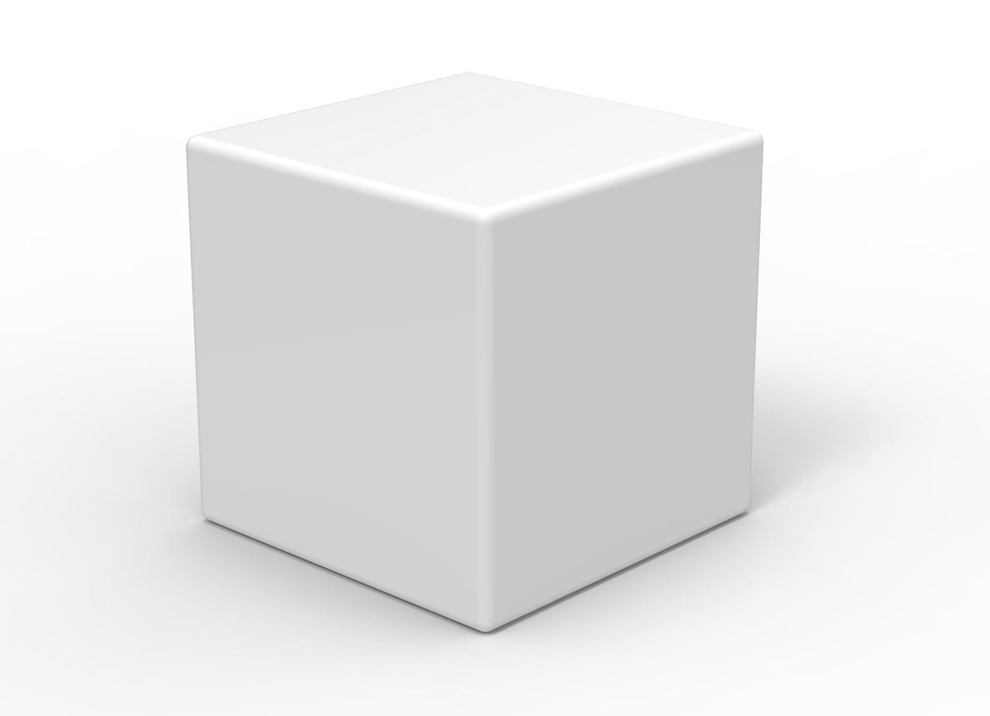
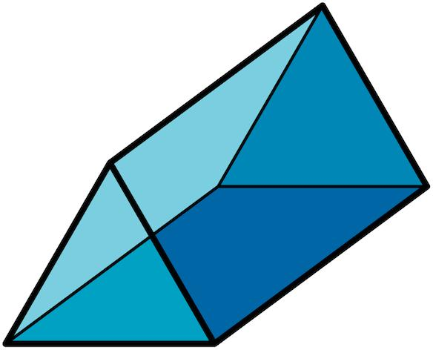
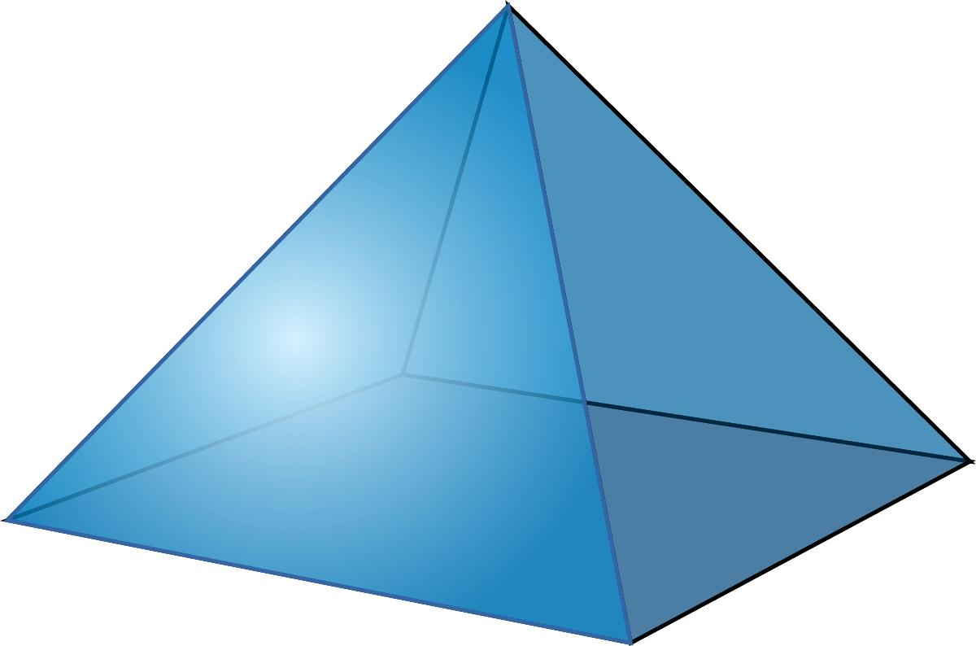

Simple Definition
# Source: AI Source: Provided by: [Data Path: Persons Table -> ID Column: 1, Name_En Column: Motasem Essam] -> From: [ChatGPT] on [7/25/2026]
A polyhedron is a solid made of flat polygonal faces joined together along straight edges.
For example, a cube is a polyhedron because it has six square faces, twelve straight edges, and eight vertices.
A sphere is not a polyhedron because its surface is curved rather than made of polygonal faces.

Classification Tree
# Source: AI Source: Provided by: [Data Path: Persons Table -> ID Column: 1, Name_En Column: Motasem Essam] -> From: [ChatGPT] on [7/25/2026]
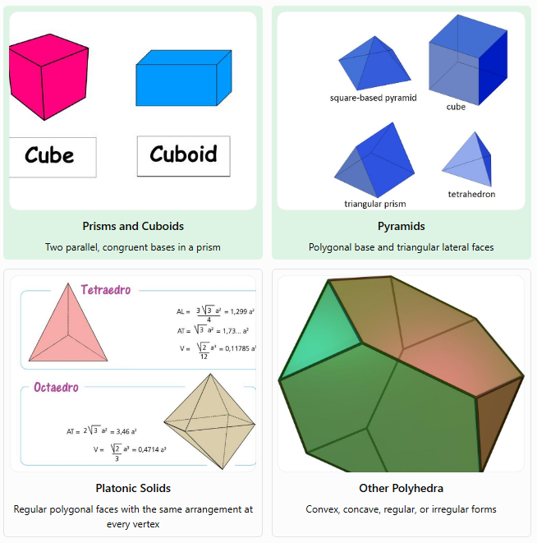
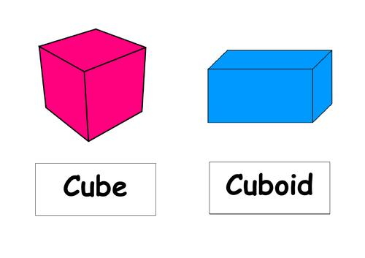
Prisms and Cuboids
Two parallel, congruent bases in a prism
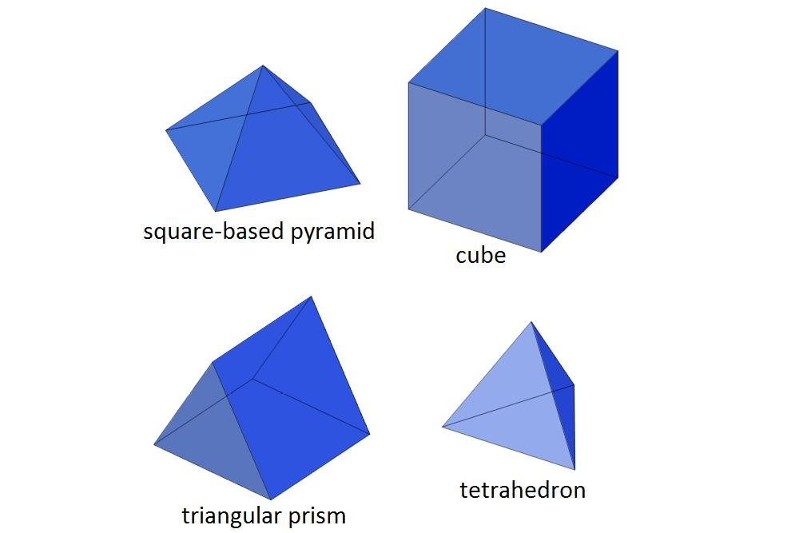
Pyramids
Polygonal base and triangular lateral faces
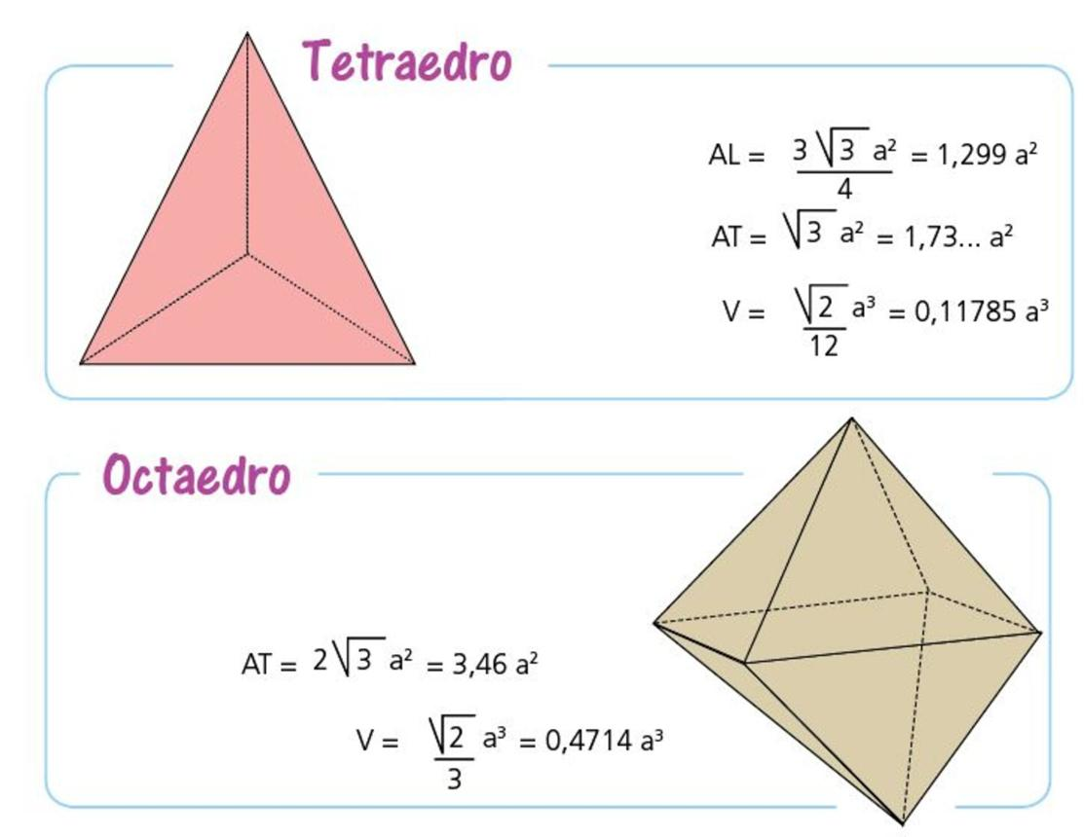
Platonic Solids
Regular polygonal faces with the same arrangement at every vertex
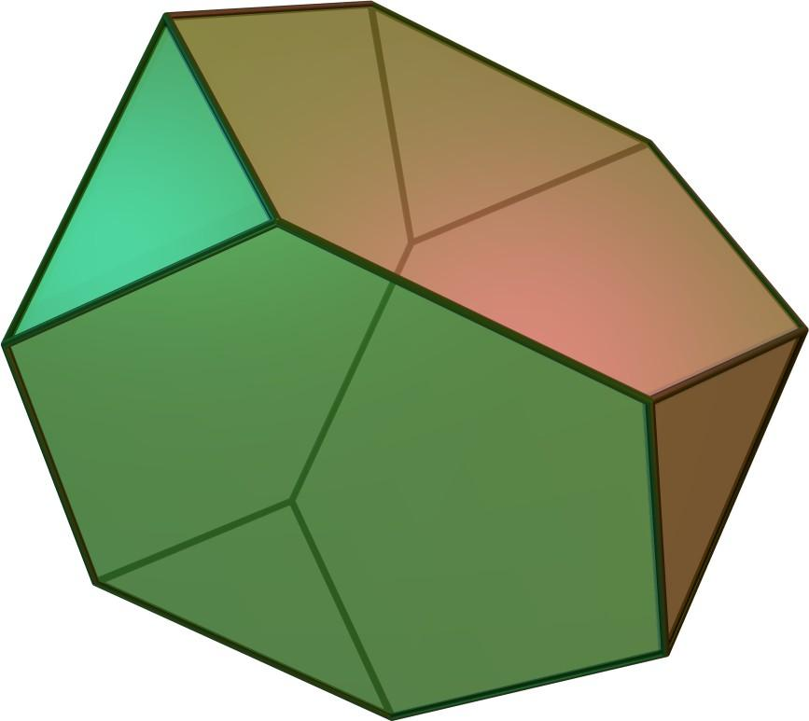
Other Polyhedra
Convex, concave, regular, or irregular forms
This is a practical classification rather than a list of mutually exclusive categories. For example, a cube is both a prism and a Platonic solid.

Key Characteristics of Polyhedra
# Source: AI Source: Provided by: [Data Path: Persons Table -> ID Column: 1, Name_En Column: Motasem Essam] -> From: [ChatGPT] on [7/25/2026]
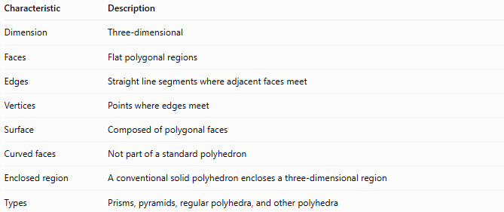
Characteristic | Description
Dimension | Three-dimensional
Faces | Flat polygonal regions
Edges | Straight line segments where adjacent faces meet
Vertices | Points where edges meet
Surface | Composed of polygonal faces
Curved faces | Not part of a standard polyhedron
Enclosed region | A conventional solid polyhedron encloses a three-dimensional region
Types | Prisms, pyramids, regular polyhedra, and other polyhedra

Geometric Representation
# Source: AI Source: Provided by: [Data Path: Persons Table -> ID Column: 1, Name_En Column: Motasem Essam] -> From: [ChatGPT] on [7/25/2026]
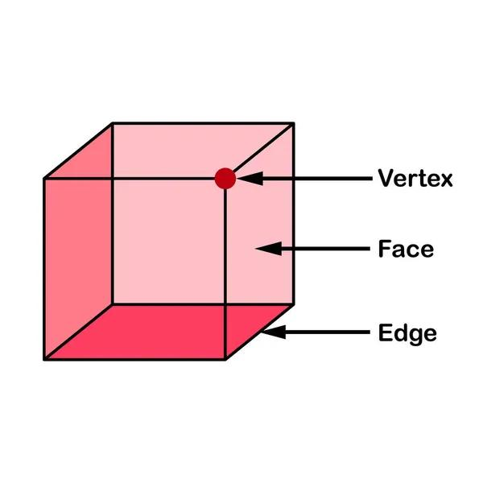
A cube illustrates the three principal elements of a polyhedron:
- Face: A flat polygon forming part of the boundary.
- Edge: A straight segment shared by adjacent faces.
- Vertex: A corner where edges meet.
For a cube:
$$V=8, E=12, F=6$$
Here, $V$ denotes the number of vertices, $E$ the number of edges, and $F$ the number of faces.

Main Types of Polyhedra

A. Prisms
# Source: AI Source: Provided by: [Data Path: Persons Table -> ID Column: 1, Name_En Column: Motasem Essam] -> From: [ChatGPT] on [7/25/2026]
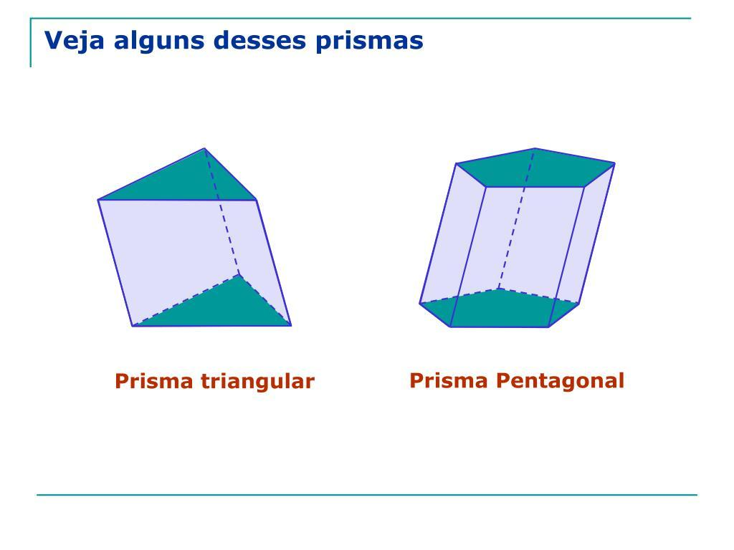
A prism is a polyhedron with two parallel, congruent polygonal bases connected by lateral faces.
Examples:
- Triangular prism
- Rectangular prism
- Pentagonal prism
- Hexagonal prism
A prism with an $n$-sided base has:
$$F=n+2, E=3n, V=2n$$
For a triangular prism, $n=3$, so $F=5$, $E=9$, and $V=6$.

B. Pyramids
# Source: AI Source: Provided by: [Data Path: Persons Table -> ID Column: 1, Name_En Column: Motasem Essam] -> From: [ChatGPT] on [7/25/2026]
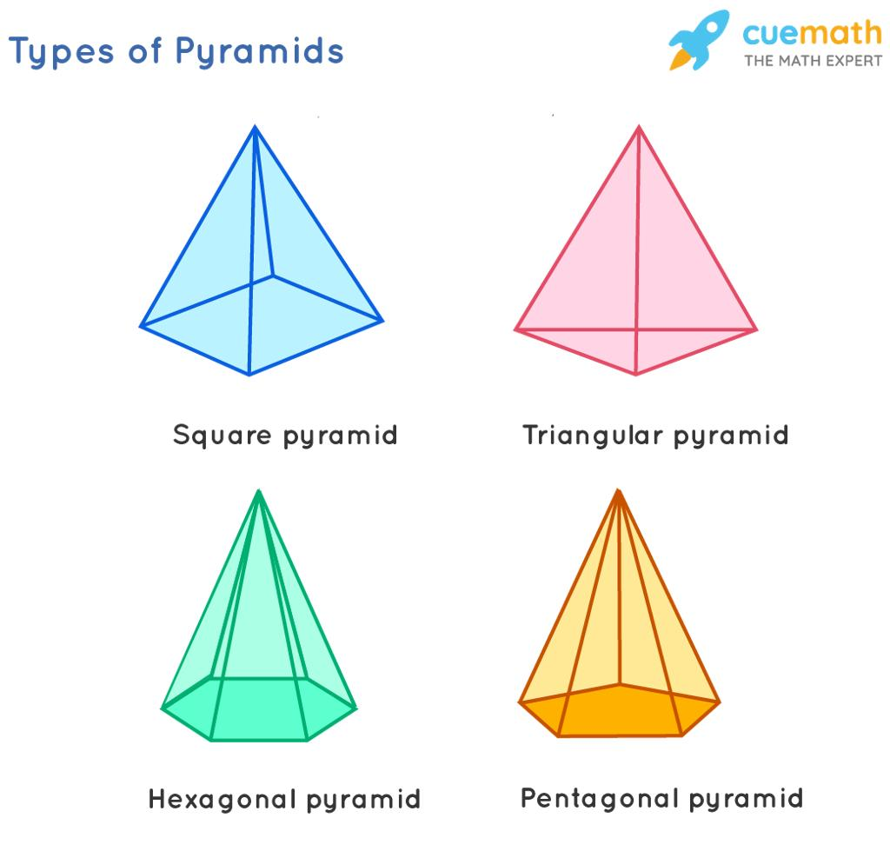
A pyramid is a polyhedron with one polygonal base and triangular lateral faces that meet at a common apex.
Examples:
- Triangular pyramid
- Square pyramid
- Pentagonal pyramid
- Hexagonal pyramid
A pyramid with an $n$-sided base has:
$$F=n+1, E=2n, V=n+1$$
For a square pyramid, $n=4$, so it has 5 faces, 8 edges, and 5 vertices.

C. Platonic solids
# Source: AI Source: Provided by: [Data Path: Persons Table -> ID Column: 1, Name_En Column: Motasem Essam] -> From: [ChatGPT] on [7/25/2026]
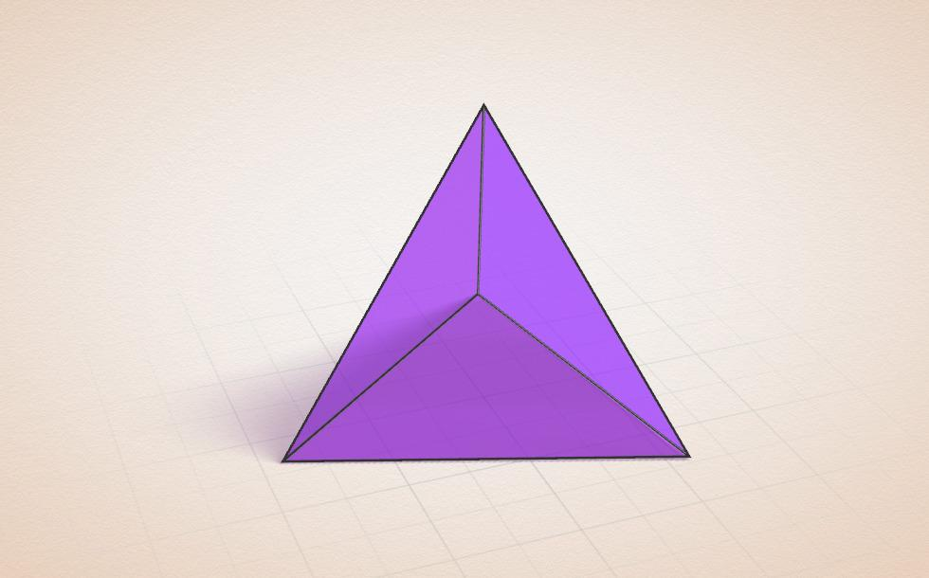
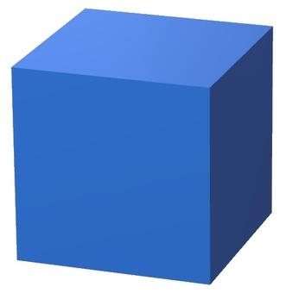
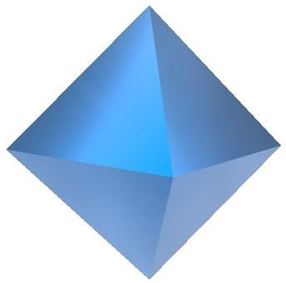
The Platonic solids are the five convex regular polyhedra. Each face is a congruent regular polygon, and the same number of faces meet at every vertex.
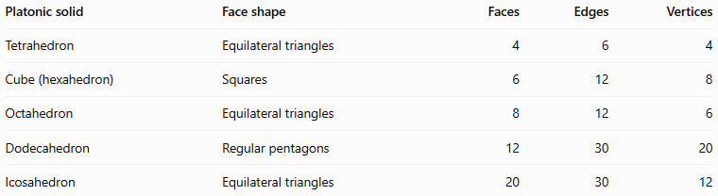
Platonic solid | Face shape | Faces | Edges | Vertices
Tetrahedron | Equilateral triangles | 4 | 6 | 4
Cube (hexahedron) | Squares | 6 | 12 | 8
Octahedron | Equilateral triangles | 8 | 12 | 6
Dodecahedron | Regular pentagons | 12 | 30 | 20
Icosahedron | Equilateral triangles | 20 | 30 | 12

D. Convex and concave polyhedral
# Source: AI Source: Provided by: [Data Path: Persons Table -> ID Column: 1, Name_En Column: Motasem Essam] -> From: [ChatGPT] on [7/25/2026]
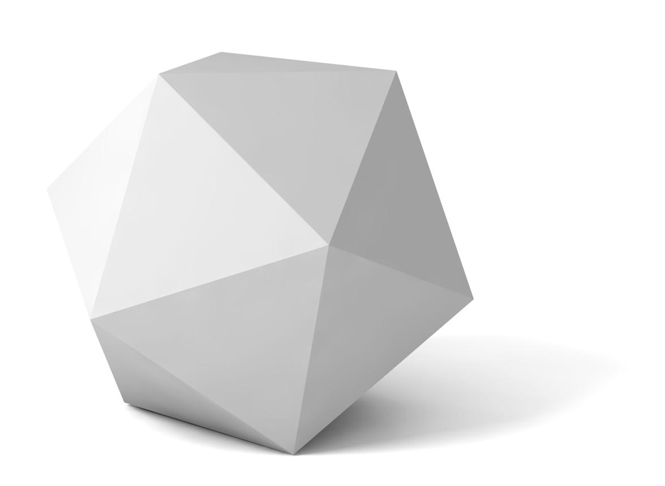
Convex polyhedron
Every line segment joining two points of the solid remains inside the solid.
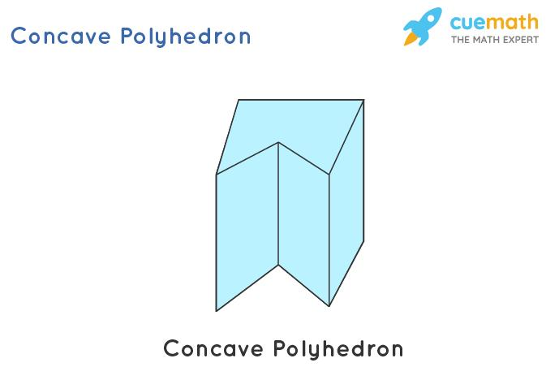
Concave polyhedron
At least one line segment joining two points of the solid passes outside the solid.
A convex polyhedron has no inward indentation. A concave polyhedron has at least one inward indentation.

Mathematical Properties and Formulas

A. Euler's formula
# Source: AI Source: Provided by: [Data Path: Persons Table -> ID Column: 1, Name_En Column: Motasem Essam] -> From: [ChatGPT] on [7/25/2026]
For a convex polyhedron, the numbers of vertices, edges, and faces satisfy:
$$V-E+F=2$$
For a cube:
$$8-12+6=2$$
This is Euler's formula for convex polyhedra. Related formulas also apply to other polyhedra under appropriate topological conditions.

B. Total surface area
# Source: AI Source: Provided by: [Data Path: Persons Table -> ID Column: 1, Name_En Column: Motasem Essam] -> From: [ChatGPT] on [7/25/2026]
The total surface area of a polyhedron is the sum of the areas of all its polygonal faces:
$$SA=A_{1}+A_{2}+⋯+A_{F}$$
where $A_{i}$ is the area of face $i$.
For a cube with side length $s$:
$$SA=6s^{2}$$

C. Volume of common polyhedral
# Source: AI Source: Provided by: [Data Path: Persons Table -> ID Column: 1, Name_En Column: Motasem Essam] -> From: [ChatGPT] on [7/25/2026]
For a prism:
$$V=Bh$$
For a pyramid:
$$V=\frac{13}{B}h$$
Here, $B$ is the area of the base and $h$ is the perpendicular height.

Worked Examples
# Source: AI Source: Provided by: [Data Path: Persons Table -> ID Column: 1, Name_En Column: Motasem Essam] -> From: [ChatGPT] on [7/25/2026]
Example 1: Identifying a polyhedron
A solid has six rectangular faces, twelve straight edges, and eight vertices. Is it a polyhedron?
Solution: Yes. It is a polyhedron because its boundary consists of flat polygonal faces joined along straight edges. If its faces are rectangles, it may be a rectangular prism or cuboid.
Example 2: Finding the number of faces of a hexagonal prism
A hexagonal prism has a hexagonal base, so $n=6$.
Using the prism formula:
$$F=n+2=6+2=8$$
Its edges and vertices are:
$$E=3n=18$$
$$V=2n=12$$
Answer: The hexagonal prism has 8 faces, 18 edges, and 12 vertices.
Example 3: Checking Euler's formula for a square pyramid
A square pyramid has:
- $V=5$ vertices
- $E=8$ edges
- $F=5$ faces
Substituting into Euler's formula:
$$V-E+F=5-8+5=2$$
Answer: The square pyramid satisfies Euler's formula.

Comparison with Other Types of Solids
# Source: AI Source: Provided by: [Data Path: Persons Table -> ID Column: 1, Name_En Column: Motasem Essam] -> From: [ChatGPT] on [7/25/2026]
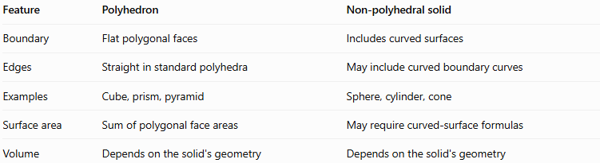
Feature | Polyhedron | Non-polyhedral solid
Boundary | Flat polygonal faces | Includes curved surfaces
Edges | Straight in standard polyhedra | May include curved boundary curves
Examples | Cube, prism, pyramid | Sphere, cylinder, cone
Surface area | Sum of polygonal face areas | May require curved-surface formulas
Volume | Depends on the solid's geometry | Depends on the solid's geometry
A cylinder and a cone have flat circular bases, but their curved lateral surfaces mean they are not polyhedra under the standard definition.

Applications of Polyhedra
# Source: AI Source: Provided by: [Data Path: Persons Table -> ID Column: 1, Name_En Column: Motasem Essam] -> From: [ChatGPT] on [7/25/2026]
- Architecture: Modeling buildings, roofs, and structural frameworks.
- Engineering: Designing components with flat polygonal surfaces.
- Computer graphics: Constructing 3D models from polygon meshes.
- Packaging: Designing boxes, cartons, and polygonal containers.
- Crystallography: Studying geometric forms of crystals.
- Mathematics: Exploring spatial relationships, symmetry, surface area, volume, and Euler's formula.

Key Points
# Source: AI Source: Provided by: [Data Path: Persons Table -> ID Column: 1, Name_En Column: Motasem Essam] -> From: [ChatGPT] on [7/25/2026]
- A polyhedron is a three-dimensional solid bounded by flat polygonal faces.
- Faces meet along straight edges, and edges meet at vertices.
- Prisms and pyramids are major classes of polyhedra.
- The five Platonic solids are the convex regular polyhedra.
- Polyhedra may be convex or concave.
- For convex polyhedra, Euler's formula is $V-E+F=2$.
- Spheres, cylinders, and cones are not polyhedra because they have curved boundary surfaces.

Conclusion
# Source: AI Source: Provided by: [Data Path: Persons Table -> ID Column: 1, Name_En Column: Motasem Essam] -> From: [ChatGPT] on [7/25/2026]
Polyhedra are fundamental objects in solid geometry. Their polygonal faces, straight edges, and vertices provide a framework for classifying three-dimensional shapes and calculating surface area and volume. Understanding prisms, pyramids, and regular polyhedra builds the foundation for more advanced topics in spatial geometry.

